Northern Lights Arts Council Scholarship
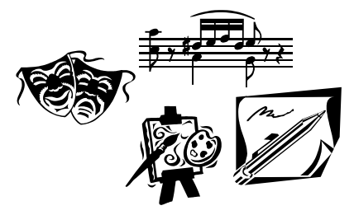
The Northern Lights Arts Council is offering a college scholarship in the amount of $400. Application deadline: May 1, 2024
Qualifications:
- Applicants must have a home residence in Cavalier County
- Applicants must be at least a graduating high school senior with a declared major or minor in the arts. (Arts being defined as music, art, drama, creative writing, design or a related field.)
- Applicants must include one recommendation from someone acquainted with your studies in the arts.

Name: _______________________________Phone #: _________________
Address, City, State, Zip: ___________________________________________
Email Address: ____________________________Date of Birth:____________
Name of parent(s) or legal guardian(s): _________________________________
Name of college planning to attend or currently attending:
____________________________________________________________
Major of Study:______________________Minor:_______________________
Signature: _________________________________ Date: _______________
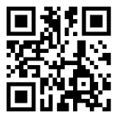
Please mail completed application to:
Northern Lights Arts Council
Attn: Scholarship
PO Box 162
Langdon, ND 58249
Or complete the application online at nlac.us/college-scholarship-application
Please have the recommendation sent to the same address.
Please answer the following questions as thoroughly as possible (use additional sheets if necessary):
- List and describe any of the following you’ve participated in and how it has contributed to your development: jobs, volunteer work, interests, activities, and/or organizations.

- How has art impacted your life or how do you plan to use your career in the arts to impact others?

- How did you hear about this scholarship? (Optional)

